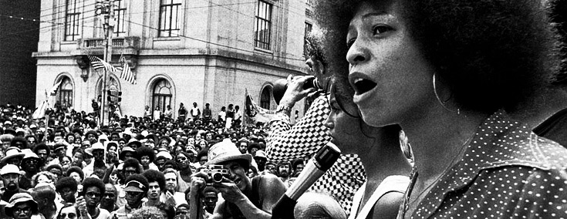
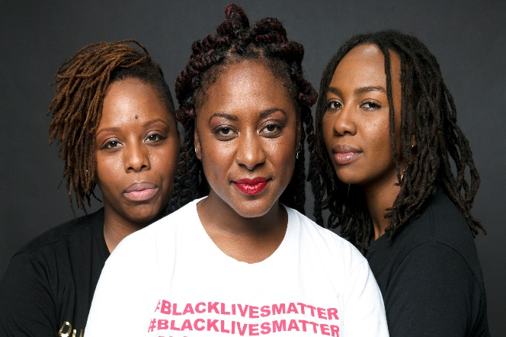
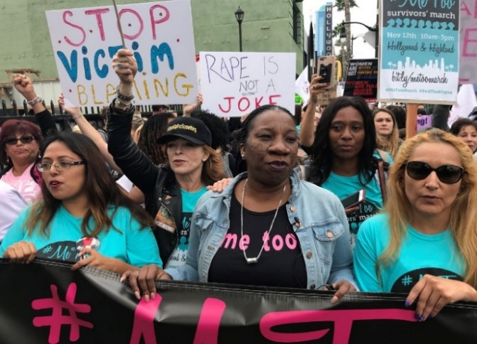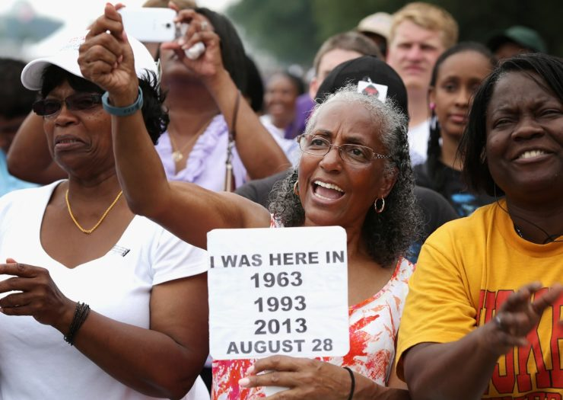

Black Women Writers:  Writing as Resistance in the Post-Civil Rights Era  Mon/Wed/Fri, 12:00pm-12:50pm (Friends304);  Tues, 4:00pm-4:50pm (Friends 210) | Office Hours  (Muller 304):  Monday, 1:00-2:30pm  Tuesday, 2:30-3:50pm  and by appointment

Course Description:
The end of the global Civil Rights era of the 1960s led many to consider issues of race, gender, sexuality, and social class “closed.” Civil rights legislation enacted in the United States, they believed, served as an armistice between governing institutions and those groups who had been traditionally marginalized by discriminatory practices. For them, this “resolution” made it unnecessary to ever again re-litigate issues of identity and marginalization in the realm of public discourse. Black women across the Diaspora immediately saw through the superficiality of this resolution, and in the years following the final moments of the era, used their writing to continue resisting the marginalization they experienced in their daily lives. As writers they flourished, publishing extensively through a variety of venues and mediums. Their written work functioned as one of the most powerful and stable engines in challenging a socially-determined politics of identity that still failed to acknowledge their equal rights. It also proved instrumental in helping catalyze the formation of Gender & Women’s Studies programs in academic institutions across the nation, transforming discourses of feminism and women’s liberation for a new generation of activists and scholars. In essence, they radically redefined womanhood, particularly for black women, through their writing. Their success raises important questions, though. As the definition of womanhood (and manhood, presumably) changes through their literature, what precisely are they resisting? What form does their resistance take considering that the signs of overt discrimination have been removed? What does resistance look like in a changing national, and increasingly global landscape?

This class will explore these questions through a collection of texts by black women that represent various forms of resistance and move us away from the single story so often applied to their lives. To make this exploration as comprehensive as possible, we will consider texts across multiple genres – choreopoem, novel, short story, analytical essay, poetry, and music/lyricism. Since this is such a diverse collection of texts, we will formulate a series of questions that will help frame our discussions and develop a set of parameters for considering the similarities and differences between them.

Because of the controversial themes and plots at work in many of these texts, we must establish ground rules for how to discuss them. First, studying literature is not an exact science, so we must be receptive to the many different textual interpretations you and your classmates will arrive at. Our unique life experiences will inevitably lead us all to distinct readings of a particular text, especially as it applies to racial and gender identities. Second, although there is no single “correct” reading of the texts under discussion, there are ways of casually misreading them. Therefore, we will ground all of our discussions and interpretations in close readings of the things an author incorporates in her piece of literature. This means you must read a text, and read it thoroughly, to understand how these elements come together to create meaning. Third, we will discuss racial and gender stereotypes when they are apparent in, or relevant to, the literature we are analyzing. This may result in moments of cognitive dissonance likely shared by your classmates, and I hope they become part of our productive class discussions. However, we will not unnecessarily impose racial and gender stereotypes on a work or its author. Last, you must give the literature a chance. I do not expect you to share my wild enthusiasm for the texts we are reading, but you mustn’t be dismissive of them without having read them.

Required Texts:
Clemmons, Zinzi. What We Lose
Durrow, Heidi. The Girl Who Fell From the Sky
Gay, Roxanne. Bad Feminist
Naylor, Gloria. The Women of Brewster Place
Raboteau, Emily. The Professor’s Daughter
Rankine, Claudia. Citizen

Course Assignments and Grading:

- Annotated Bibliography [20%]
- Narrative Analysis Essay [20%]
- Build Your Own Course [20%]
- Workshop Portfolio [30%]
- Active Participation [10%]

Standard Percentage Equivalencies for the course:
100 – 90% = A, 89 – 80% = B, 79 – 70 = C, 69 – 60 = D, 60> = E

A final grade of Incomplete (I) can be awarded only in very special circumstances that you have discussed with the instructor ahead of time.

Annotated Bibliography: You will compile an annotated bibliography of 7-10 entries for texts that have a thematic connection to this course. Three of your selections can be derived from authors whose works we are already reading (Lorde’s essays and chapters by Angela Davis and Alice Walker) but the others need to come from sources you are finding on your own. Entries will be 6-8 sentences in length, will articulate the main point an author makes, will adequately summarize the work, and will detail the connection you are making between it and our course. More instructions are available on Canvas.

Narrative Analysis Essay: You will be piecing together an account of the development of your relationship with the subject matter over the course of the semester. Think of the assignment as a mapping and/or articulation of your journey through the writing of our authors. That journey may be intellectual, emotional, psychological, even spiritual. Use creative language to tell your own story.

Build Your Own Course: Utilizing your newfound knowledge of the experiences of the black women whose work we read, you will design your own undergraduate-level course of the same topic. This will include crafting a syllabus, designing an assignment sheet for one of the major assignments, and then writing up a justification for the value of your course.

Workshop Portfolio: Over the course of the semester, you will reply to a series of writing prompts (15 in total) that will be submitted to Canvas as a portfolio reflecting your insights. Most of the writing will take place during our Tuesday workshop, and several of the entries will connect directly to the major assignments you will work to complete. There is no specific length for entries, though quality entries should be detailed and well-written. They are graded as credit/no-credit and I will let you know via Canvas comments if you have NOT met the minimum requirement for an entry.

Attendance/Participation: Your presence in the class is only a part of your participation in this course. In my experience, the most interesting classes are the ones in which students contribute more to class discussions than the instructor. Honestly, nobody wants to listen to me ramble on and on. You need to come to class having closely read the assigned material and prepared to discuss your analyses. Treat every class as though you will have to speak on a particular subject and/or text for at least a few minutes.

Course Policies:
Students with Documented Disabilities
A translation of the legal-speak below – I want to make this course accessible to all, including those students with physical and/or learning disabilities, whatever they may be. Registering with SAS is often the first step in the process, but it is important that you raise my own awareness of any specific concerns you may have or of alternate teaching techniques, assignments, etc. that will maximize what you learn in our class and also your participation in it: In compliance with Section 504 of the Rehabilitation Act of 1973 and the Americans with Disabilities Act, reasonable accommodation will be provided to students with documented disabilities on a case by case basis. Students must register with the Office of Student Disability Services and provide appropriate documentation to the college before any academic adjustment will be provided.

Attendance
It feels much easier to miss class when it is administered synchronously online, but your presence is required at every one of our scheduled class sessions. You are also expected to arrive on time. Arriving 10 minutes late for class will count as half an absence. Anything more the 10 minutes counts as a full absence. Both will result in a reduction in your overall grade. I am well aware of the unpredictable madness of everyday life taking place beyond the boundaries of Ithaca College, especially amid the COVID pandemic. Therefore, you will be granted three excused absences over the course of the semester. Just be certain to inform me of your absence as early as possible. On your sixth absence from class (essentially three full weeks of class time), you will be administratively dropped from the course.

Classroom Conduct
This one is simple – use your manners and be respectful of others! I expect your audio to be muted until you are contributing to the discussion, and your video to always be unmuted unless you have informed me otherwise before class.

Plagiarism
The theft of the intellectual property of another individual or entity, whether it be purposeful or unintentional, is a serious offense that carries with it severe consequences. The offender will immediately fail the assignment with no chance for resubmission and will have to meet with me outside of class to discuss the infraction. The circumstances behind the plagiarism may warrant even further action as outlined in the Student Handbook. Refer to the Student Conduct Code (http://www.ithaca.edu/policies/vol7/volume_7-70102/), the “Plagiarism” library tutorial, or visit me during office hours if you have further questions.

Course Schedule:

COURSE DATE | MATERIALS TO BE READ BEFORE CLASS | ASSIGNMENTS DUE
1/22 | Introduction / Syllabus Review
1/23 – Workshop | NO CLASS | Read for class on Wednesday
1/24 | “White Professors, Black History…” (Nobile, Fleming, and Asante) and  “The Danger of a Single Story” (Adichie) – both on Canvas | Entry 1: What do you want to get from this course? What will you give to it?
1/26 | “The Civil Rights Movement: What Good Was It?” & “In Search of Our Mother’s Gardens” (Walker) – both on Canvas | Entry 2: Who are you? How does your identity relate to being a student in this course?
1/29 | The Women of Brewster Place (pps 1-54)
1/30 – Workshop | Understanding/Defining Yourself as a Reader | Entry 3: What are your strengths as a reader? Challenges?
1/31 | The Women of Brewster Place (pps 55-88)
2/2 | The Women of Brewster Place (pps 89-106) | Entry 3 due
2/5 | The Women of Brewster Place (pps 107-174)
2/6 – Workshop | Understanding/Defining Yourself as a Writer | Entry 4: What are your strengths as a writer? Challenges?
2/7 | The Women of Brewster Place (pps 175-197)
2/9 | “The Meaning of Freedom” (Davis) – on Canvas | Entry 4 due
2/12 | “Justice for Lesbian, Gay, Bisexual, and Transgender Communities (Davis) – on Canvas
2/13 – Workshop | Creating Annotated Bibliographies | Entry 5: Initial ideas for locating and evaluating texts
2/14 | “Uses of the Erotic” (Lorde) – on Canvas
2/16 | “The Master’s Tools” (Lorde) – on Canvas | Entry 5: due
2/19 | The Girl Who Fell From the Sky (1-43)
2/20 – Workshop | Creating Annotated Bibliographies | Entry 6: What have you learned from your classmate?
2/21 | The Girl Who Fell From the Sky (44-94)
2/23 | The Girl Who Fell From the Sky (95-121) | Entry 6: due
2/26 | The Girl Who Fell From the Sky (122-183)
2/27 - Workshop | Creating Annotated Bibliographies | Entry 7: How can you use this in designing your course?
2/28 | The Girl Who Fell From the Sky (184-234)
3/1 | The Girl Who Fell From the Sky (235-264) | Entry 7: due
3/4 | What We Lose (Part One)
3/5 – Workshop | Understanding Attributes Integral to Helpful Peer Review | Entry 8: Provide examples of each form of feedback
3/6 | What We Lose (Part Two)
3/8 | What We Lose (Part Three) | Entry 8: due
3/9-3/17 | SPRING BREAK! NO CLASSES!!
3/18 | “The Bean Eaters,” “Primer for Blacks” (Brooks) and “The Black Unicorn” (Lorde) – on Canvas
3/19 – Workshop | Building Your Own Course | Entry 9: What are your goals for the course?
3/20 | “One for All Newborns” (Yona), “for the kids who live” (Monet), “Incident,” “Miscegenation” (Tretheway) – on Canvas
3/22 | Citizen (1-37) | Entry 9: due
3/25 | Citizen (38-79)
3/26 – Workshop | Building Your Own Course | Entry 10: Why would students want to take it?
3/27 | Citizen (80-118)
3/29 | Citizen (119-163) | Entry 10: due
4/1 | The Professor’s Daughter (1-68)
4/2 – Workshop | Building Your Own Course | Entry 11: How would you feel teaching it?
4/3 | The Professor’s Daughter (69-92)
4/5 | The Professor’s Daughter (93-126) | Entry 11: due
4/8 | APRIL BREAK! NO CLASSES!!
4/9 – Workshop | APRIL BREAK! NO CLASSES!!
4/10 | The Professor’s Daughter (127-220)
4/12 | The Professor’s Daughter (221-246)
4/15 | The Professor’s Daughter (247-276)
4/16 – Workshop | Planning for the End of the Semester | Entry 12: What steps do you need to take?
4/17 | Bad Feminist (xi-60)
4/19 | Bad Feminist (61-108) | Entry 12: due
4/22 | Bad Feminist (109-169)
4/23 – Workshop | Writing Narrative Analysis Essays | Entry 13: Revisit your first entry. Changes?
4/24 | Bad Feminist (170-226)
4/26 | Bad Feminist (227-266) | Entry 13: due
4/29 | Bad Feminist (267-320)
4/30 - Workshop | Writing Narrative Analysis Essays | Entry 14: Most impactful moment? Least impactful?
5/1

5/3 |  | Entry 14:
5/6 | Student Statements on Teaching
5/7 – Workshop | Writing Narrative Analysis Essays | Entry 15: What have you given to this class? Gotten?

