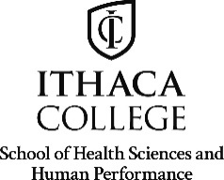 | 2021 EMERSON SUMMER INTERNSHIP PROGRAM  SITE CONFIRMATION  (all information must be typed)

Ithaca College offers five undergraduate awards to support summer internships for rising senior students. The student who will be interning at your site has applied for an award, therefore, we need to receive confirmation of this placement from you. By signing this form you will provide us with verification that this student will be completing an internship at your facility during the Summer Session 2021. Please check the box indicating that you have read and approve the activities. If you have any additional comments, please write them in the space provided. After signing the form, please return it to the Deans Office at the address listed below.

I, confirm the acceptance of as an intern during the Summer Session 2021 at .

Start Date: | End Date: | *Credits:

I have read and approve the activities as described in the intern’s design statement.
Additional comments:

SIGNATURES

IC Faculty Sponsor/advisor/internship coordinator |  | Signature |  | Date
Authorized Site Supervisor |  | Signature |  | Date

Thank you for your prompt attention and return of this document by FAX or Mail. Form must be received on or before 4:00 pm on Monday, March 15, 2021 If you FAX us a copy, please put the original in the mail for our files.

Ithaca College | Phone: 607.274.3237
School of Health Sciences and Human Performance | Fax Number: 607.274.1137
Deans Office
320 Smiddy Hall
Ithaca, NY 14850

