**Faculty / Staff Meal Plan Registration Form**

Name:____________________________________________________

Employee number:_________________________________________

Phone:___________________ Email:__________________________

**Meal Plan Options** (check one)

_____ 10 meals for $ 57.50 ($5.75 per meal)

_____ 20 meals for $110.00 ($5.50 per meal)

_____ 40 meals for $210.00 ($5.25 per meal)

_____ 80 meals for $400.00 ($5.00 per meal)

***There will be no refund on unused meals if you leave***

***your employment at Ithaca College.***

**Payment Method**

____ **Cash**

____ **Check**

____ **Credit card** (please pay in person)  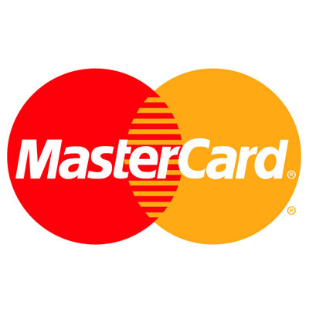 

 ____ **Payroll deduction**: (check one) **Bi-weekly** ______ **Semi-Monthly** ______

**(every 2 weeks) (15th and last day of each month)**

I authorize the Ithaca College Payroll office to deduct $_________ (**divide total by 1, 2, 3, or 4**) from my paycheck **per pay period**, up to four consecutive payments.

Employee signature: _____________________________ Date: _____________

**(month and date)**

Pay Date#1__ **/**___ Pay Date #2 ___ **/**___ Pay Date #3 ___ **/** ___ Pay Date #4 ___ **/**___

**Call Dining Services:**

**4-1187**

**Fax to Dining Services**:

**4-5703**

**Scan and e-mail to Dining Services**:

**dine@ithaca.edu**

**please do not e-mail a photo of this form**