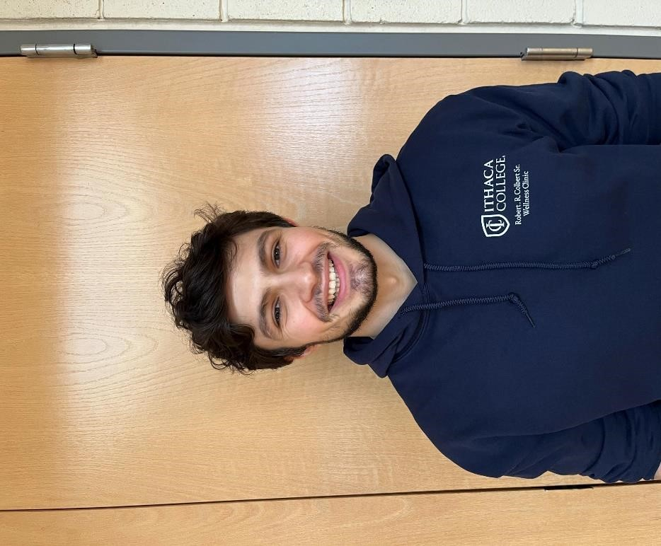
Meet Mike
I am a junior Exercise Science/Sports Sciences major from a small one stoplight town called Sherburne, NY. I’ve always been active, whether that was playing sports in high school, having to walk miles on Oneida Lake to find where the Walleye are, traversing through the woods to find a tree to climb during deer season, or catching King Salmon on Lake Ontario during the summer. Most of my free time is spent running, trying out cool kettlebell workouts courtesy of Bill Eshe- The Kettlebell Warrior, training jiu jitsu, and staying close to my faith.

Mobility with Mike
Mobility with Mike is a midday exercise class targeting improved functional movement patterns. We do this by integrating dynamic stretching, mobility drills, and calming exercises. Tailored for the midday schedule, it offers a brief 30-minute break to help promote movement and get you over that midday hump. The combination of gentle movements finishing with mindful breathing will leave you energized and ready to tackle the rest of the day with improved overall mobility and functionality.

Day and Time
Wednesday 12-12:30 PM

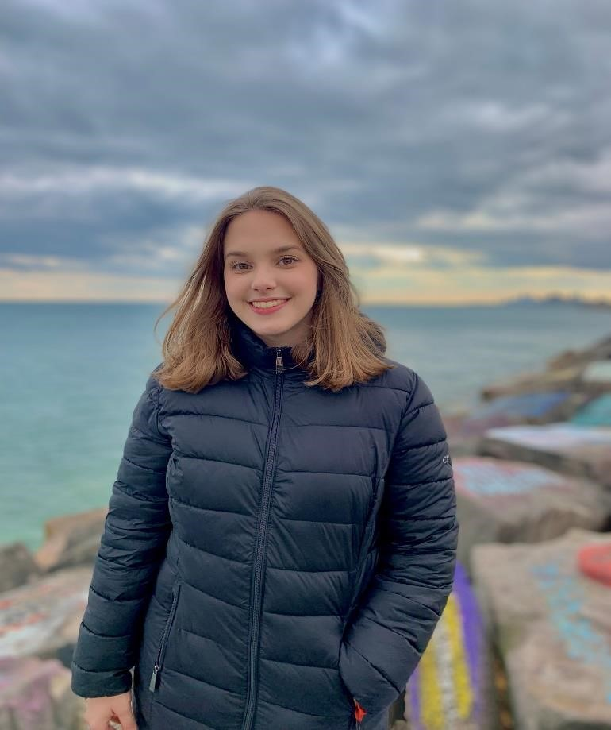
Meet Leticia
I am an Exercise Science/Athletic
Training major. I started practicing HIIT and training for judo competitions in middle school. My parents were athletes and motivated my brother and me to practice different sports. I was a competitive athlete in judo and got my black belt when I was 16. I am super excited to teach HIIT classes as I implemented this technique during the pandemic to work out with my mother at home.

HIIT with Leticia
HIIT, or High-Intensity Interval Training, is a fitness programming technique utilizing short, intense bouts of work followed by brief, and sometimes active, recovery periods (that can be done in a moderate intensity if desired). HIIT is a great way to maximize your time and results in the gym, and it is guaranteed to make you sweat! Experienced exercisers are encouraged to work at or near maximal effort, while beginners are coached on the quality of movements before advancing to higher intensities. HIIT classes will focus on constantly varied functional movements that target the body utilizing balance, agility, speed, power, strength, endurance, and mindset. You can count on HIIT for a great workout!

Day and Time
Tuesday & Thursday 5:10-6PM

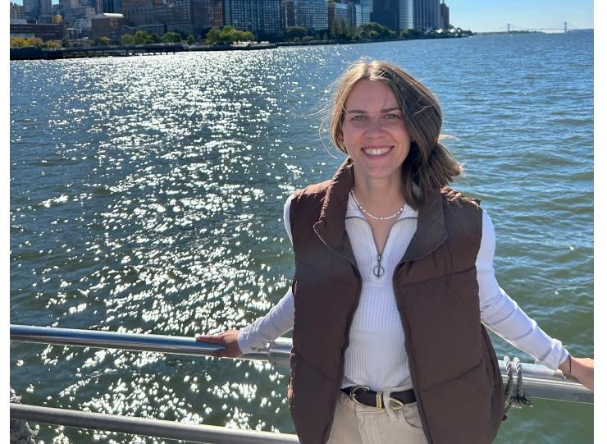
Meet Birte
I am a certified NSCF Personal Trainer. I’m originally from Germany and came to the US in 2018 to play soccer for the University of Maine. I’ve played soccer since I was 5 years old and played for the women’s Bundesliga. After graduating from Maine, I decided to further my education in occupational therapy, and I am very happy to be part of this community! I love to go hiking and spend time with friends and family. Can’t wait to see you here!

Foam Rolling with Birte
This class focuses on releasing tension and improving flexibility. We will begin the class with a series of dynamic stretches aimed at preparing your muscles for the deep release that follows. After that we will do some foam rolling. Enjoy rolling away tightness, improving circulation, and enhancing your body’s natural range of motion. We will finish with a calming cool down.

Day and Time
Wednesday 5:00-5:50 PM

Glute Core Fusion with Birte
This high-energy class is focusing on two powerhouse areas: your glutes and abs. This class will utilize bodyweight, resistance bands, and light weights to build muscle and improve fitness. Each class starts with a warm-up and ends with a cool down/relaxation time to maximize the benefit to your body and mind.
Day and Time
Monday 5:00-5:50 PM

Meet AJ
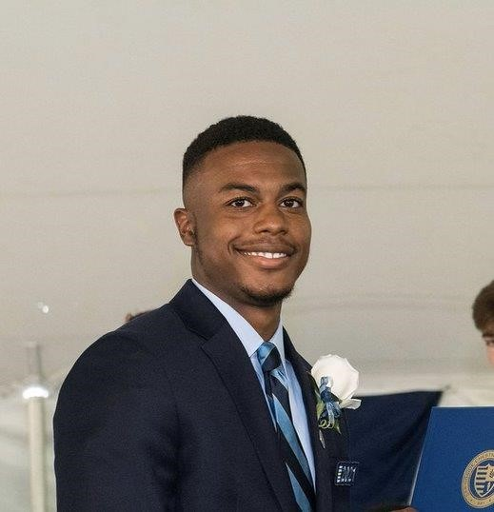
Hi, my name is AJ. I am a junior here at IC, majoring in Exercise Science with a concentration in Strength and Conditioning. My journey with fitness started at a very young age with playing football and getting into weightlifting through my family of personal trainers and athletes. My favorite lifts are any type of Olympic lift and training with Kettlebells.

Kettlebell Kraze with AJ
Kettlebell Kraze brings variation to typical strength training sessions, adding a new stimulus to your training while still creating the same movements found in your average weightlifting session. This class aims to improve stability, mobility, and overall strength through different Olympic and compound movements. From basic swings to high level Olympic lift movement progressions this class is perfect for all levels. Hope to see you there!

Day and Time
Tuesday 11:30 AM-12:20 PM
Thursday 12:00-12:50 PM

Meet Emily
I am a senior Athletic Training student and a NASM certified personal trainer. My fitness journey began sophomore year of college after recovering from an injury freshman year. While searching for new ways to stay healthy, I decided to join both the club basketball and club soccer team here at IC. I am very passionate about helping others fall in love with all forms of exercise and healthy movement. I am excited to share my passion for health and fitness here at the clinic by creating fun and beneficial workout classes that everyone can do regardless of their fitness level.

HIIT with Emily
Rise and shine with our new early-morning HIIT class! Get ready to kickstart your day with a high-energy workout designed to boost metabolism, burn calories, and leave you feeling ready for the day. HIIT training uses short bursts of high-intensity training followed by recovery periods of low-intensity training. The goal when doing this training is to push your body the hardest you can during the high-intensity periods and then recovery during low-intensity periods. The popularity of HIIT training is due to the benefits it can provide.

Day and Time
Monday 6:30-7:20 AM

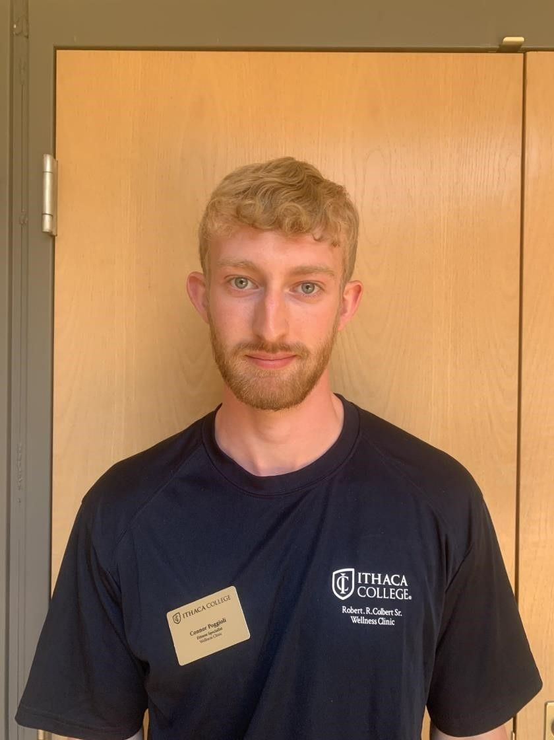
Meet Connor
I am a 4th year Physical Therapy student and Sports Psychology minor. I came to Ithaca to play Varsity Baseball for the first two years of my college career before transitioning to the coaching staff where I am currently an assistant coach for the team and work on player development. I have a strong background in sports having competed in track, baseball, basketball, soccer, golf, downhill skiing, and many more either privately or throughout HS and college. Since turning to the coaching side of things, I have been fortunate to work as an intern Strength and Conditioning coach for many professional athletes in the MLB, NFL, NHL, and MLL. I am a NASM Performance Enhancement
Specialist, and I have passed the NSCA Certified Strength and Conditioning Specialist exam pending completion of my bachelor's degree. In my downtime I love to play golf, travel, and workout.

Stretch & Core
Join us for a 5-minute general body warm-up, 20-minute static stretch, and 20-minute core workout. Core workout includes traditional mat work, balance, and standing core exercises. After class instructor is happy to connect and answer any exercise, nutrition, health, or wellness questions!
Zoom Link: https://ithaca.zoom.us/s/99507166470
Meeting ID: 995 0716 6470
Passcode: 758827

Day and Time
Tuesday and Thursday: 7-7:45 AM

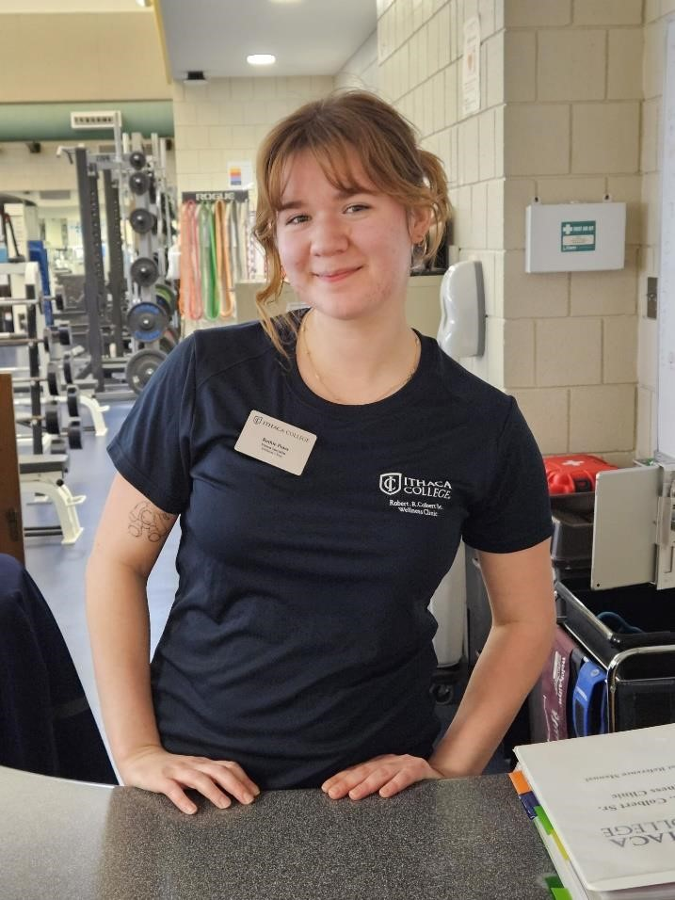
Meet Ruthie
I am a certified personal trainer and a sophomore public health major with an exercise science minor. I love to exercise, especially weightlifting, and I have taken many cycling classes in my life. The classes I’ve taken in the past were always a fun experience that provided me with a good workout. I used to always go to cycling classes with my dad, so those memories are especially fond. I find cycling to be an excellent form of cardio for how easy it is on the body. This has been helpful for me when I struggled with a foot and ankle injury. In addition to exercise, I also like to collage, knit, read, listen to music, and learn new things. My favorite muscle group to hit is legs because it makes me the most tired. In the future I hope to work with underserved communities in nutrition programs and reproductive health.

Cycling with Ruthie
This class offers a fun-filled, high-intensity workout! It is structured around an upbeat music playlist to encourage different styles of cycling, from fast-paced sprints to slow climbs and more! Each class will start with a warm-up to prepare the body for increased intensity and end with a cool down to promote recovery.

Day and Time: Monday 4 - 4:50 PM

Full Body Bootcamp with Ruthie
This class will focus on building muscle and improving overall fitness utilizing resistance bands and light weights. Each movement can be tailored to all fitness levels, working each muscle group in a mixture of compound and isolation exercises, while using proper technique to ensure safety. The class will end with a cool down and stretch to recover.

Day and Time: Friday 1-1:50 PM

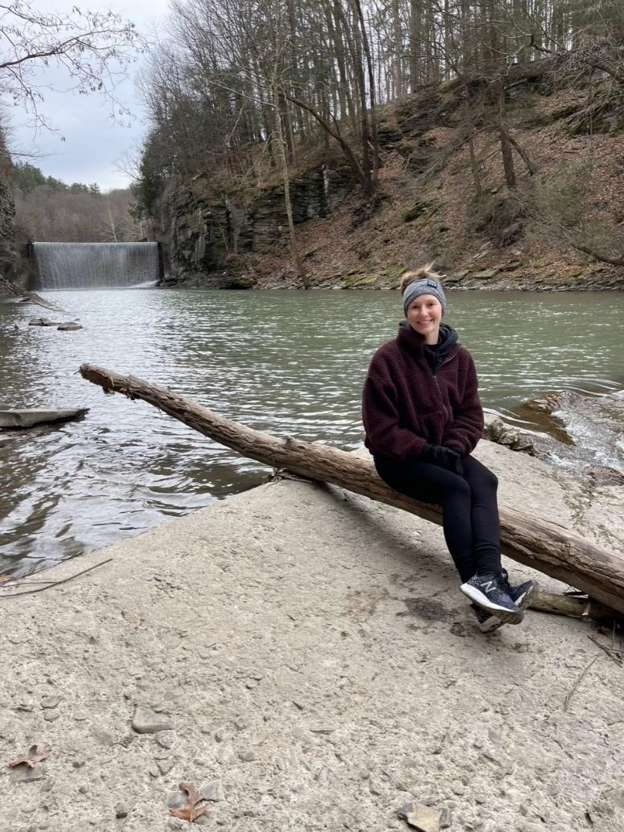
Meet Angela
My name is Angela Di Francesco – I am a Doctor of Physical Therapy with a board certification in neurologic Physical Therapy. Within the group fitness realm, I teach yoga, barre and pilates. I have been teaching yoga since 2015 and have been teaching barre and pilates since 2016. I aim for fun, challenging beat-based classes with an emphasis on alignment and activation. I have taught in several different settings including studios, large gyms, sports teams, and to individuals with neurologic diagnoses. I love to create fun programming that is tailored to class goals and abilities. All levels are welcome in my classes - I hope to see you there!

Pilates with Angela
Find mobility and stability with alignment-based movement designed to strengthen and lengthen. This class is accessible for all levels as a primary form of exercise or supplement to your usual programming.

Day and Time
Tuesday 4:15 – 5:00 PM

Yoga with Angela
Move and flow with this full-body class designed to open and strengthen the body. Come find peace and power in your body and mind. All levels are welcome!

Day and Time
Thursday 4:15-5:00 PM
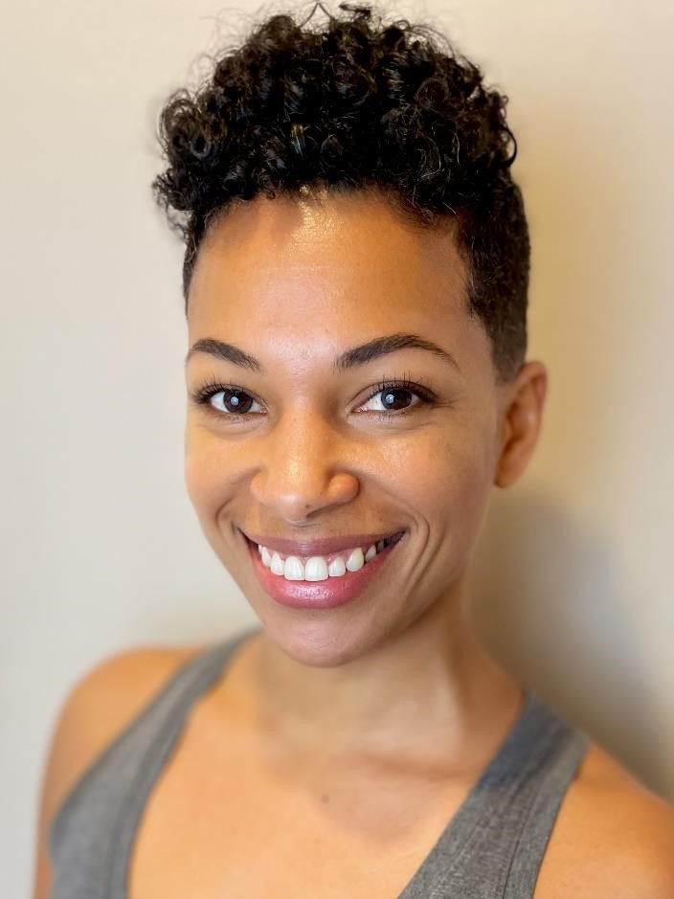

Meet Zarra
I am a 500-hour Registered Yoga Teacher and have been teaching weekly yoga classes since 2019. I strive to create unique and enjoyable yoga classes, group fitness classes, and personal training sessions. I also aim to empower my students to move their bodies with the intention to maximize effectiveness and prevent injury.

Yoga
This 60-minute session is designed to enliven the body and shift stagnant energy, allowing participants to feel revived and ready to tackle the rest of the day. Descriptive cues will be used to guide participants through traditional yoga poses in a way that promotes an intuitive relationship to movement. Many pose variations will be given to make each yoga class accessible to both beginner and experienced participants.

Days & Time

Tuesday 12:30- 1:30 PM

