
ENG 460 – Seminar in American Literature:
Toni Morrison Across the Decades
Mon/Wed, 2:00-3:15pm, Fri, 2:00-3:00 Smiddy 432
Office Hours (Muller 304):
Mon, 10:00-10:50am, Tues, 2:30-4:00pm and by appointment

Course Description:
Upon her recent death in August 2019, headlines boldly proclaimed Toni Morrison a “towering novelist,” “godly,” and “perhaps the greatest writer of her time.” They are part of a longstanding narrative of her surreal talent in telling powerful stories that ripple through the darkest parts of this nation’s history. In this way, she became a mythical figure to many of her readers, particularly those who uncritically accept the narrative of her skill as a writer. Our course will approach her mythic status critically by centralizing the question “What makes any author a great writer?” How does Morrison’s collective body of work measure up to the literary standards scholars have created to assess literature? We will consider specific qualities of her work that fuel the narrative about her writing, paying particular attention to motifs such as home/homelessness, memory, family, trauma, violence, love, and history. Our focus will also include Morrison’s depiction of race, gender, sexuality, and social class within various historical contexts. We will explore one of her novels from each decade – Song of Solomon (1977), Beloved (1987), Jazz (1992), A Mercy (2008), God Help the Child (2015) – devoting multiple weeks to each, in an attempt to cover the breadth of her writing.

As part of our exploration into her work, we will consider how deeply politicized issues of race, gender, sexuality, and social class over the last five decades might shape a reader’s understanding of the material and how the material influences our understanding of those same identity categories and the ways they transform over time. Because of the cognitive dissonance this is likely to generate we must establish ground rules for how to conduct our discussions. First, studying literature is not an exact science, so we must be receptive to the many different textual interpretations you and your classmates will arrive at. Our unique life experiences will inevitably lead us all to distinct readings of a particular text. Second, although there is no single “correct” reading of the texts under discussion, there are ways of casually misreading them. Therefore, we will ground all of our discussions and interpretations in close readings of the things Morrison (or her critics) incorporates in her literature. This means you must read a text, and read it thoroughly, to understand how these elements come together to create meaning. Last, you must give the literature a chance. I do not expect you to share my wild enthusiasm for the texts we are reading, but you mustn’t be dismissive of them without having read them.

Required Materials:

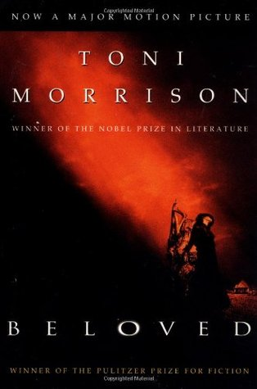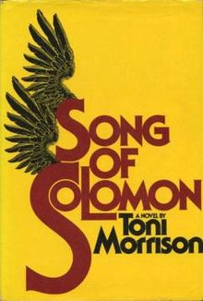
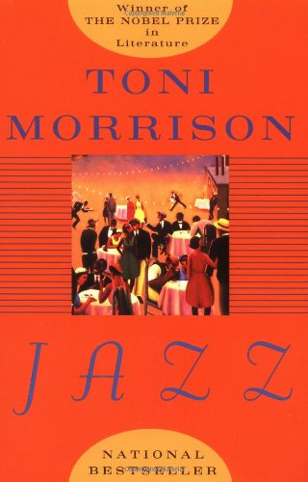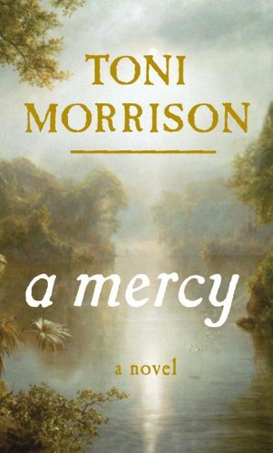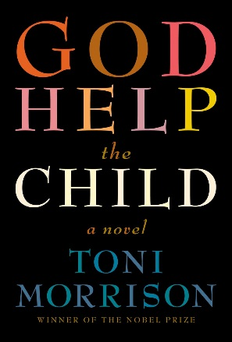

Song of Solomon (1977)
Beloved (1987)
Jazz (1992)
A mercy (2008)
God Help the Child (2015)
*Additional required materials will be made available to you via our Canvas site

Assignments & Grading:
Book Review Responses [20%]
Critical Essay Responses [20%]
Option One, Two, or Three [50%]
Attendance/Participation [10%]

Standard Percentage Equivalencies for the course:
100 – 90% = A, 89 – 80% = B, 79 – 70 = C, 69 – 60 = D, 60> = E

A final grade of Incomplete (I) can be awarded only in very special circumstances that you have discussed with the instructor ahead of time.

Book Review responses: These assignments are meant to keep you in the practice of articulating your own argumentative claims cogently and concisely as you engage the literature for the course. We will be reading popular critical reviews of each of Morrison’s novels for context. Your response to a book review will be an evaluation of its merits: what parts do you agree or disagree with and why, how accurate do you believe the review is, what else is there to consider, etc. Think about this assignment as a way of entering the critical discourse on this piece of literature. Responses should fall between 600-750 words and need to be uploaded to Canvas before the class session during which we will discuss it in class.

Critical Essay responses: These assignments are intended to help guide you through reading the secondary sources for our course. You will be determining and summarizing one of the central ideas an author presents in their work, identifying and paraphrasing three moments from a text that connect with this argument, and proposing a series of discussion questions related to it that can be used to generate in-class discussion. Along with a partner, you will be sharing your discussion questions with the class for one of the assigned secondary readings. Responses need to be uploaded to Canvas before the class session during which we will discuss it in class.

Attendance/Participation: Your presence in the class is only a part of your participation in this course. In my experience, the most interesting classes are the ones in which students contribute more to class discussions than the instructor. Honestly, nobody wants to listen to me ramble on and on. You need to come to class having closely read the assigned material and prepared to discuss your analyses. Treat every class as though you will have to speak on a particular subject and/or text for at least a few minutes.

Option One – The Seminar Paper: The purpose of a seminar paper is to allow you to more fully articulate the scope of a well-developed thesis. Seminar papers present textual evidence from a primary source (i.e. Morrison’s Beloved) and a series of secondary sources (i.e. Christian’s “Fixing Methodologies”) that illustrate the nuances and complexities of the argument you are making about the primary text. Too, the paper will explain the greater significance of your argument in relation to what other critics have written about your subject matter. The seminar paper must include at least six secondary sources and a bibliography, be written and formatted according to MLA guidelines, and fall between 2500-4000 words. The seminar paper will constitute 50% of your overall grade.

Option Two – Split Decision: Sometimes choosing a single text to write on is difficult, especially if you are equally moved by more than one work; therefore, you may choose to write on more than one novel. The format will be similar to that of the seminar paper – a well-developed thesis supported by textual evidence – but your scope will be a little more condensed. Utilizing three secondary sources for each text you write on, you will compose two different essays that outline the nuances and complexities of your own critical interpretation of the material. The two essays must include a bibliography, be written and formatted according to MLA guidelines, and fall between 2000-2500 words apiece. Each essay will constitute 25% of your overall grade.

Option Three – The Master Researcher: One of the most effective ways to process literary criticism is to hone your own assessment skills. In this course, the book review is one of the primary forms of criticism we engage and for this option you are being tasked with becoming an expert book reviewer. You will begin by assembling an annotated bibliography that illuminates the research conducted on one of Morrison’s novels. Then, you will compose your own fully developed book review (2000 words) on that same novel based on the materials you consulted for your bibliography. The bibliography and book review will each constitute 25% of your overall grade.

Course Policies:

Students with Documented Disabilities
A translation of the legal-speak below – I want to make this course accessible to all, including those students with physical and/or learning disabilities, whatever they may be. Registering with SAS is often the first step in the process, but it is important that you raise my own awareness of any specific concerns you may have or of alternate teaching techniques, assignments, etc. that will maximize what you learn in our class and also your participation in it: In compliance with Section 504 of the Rehabilitation Act of 1973 and the Americans with Disabilities Act, reasonable accommodation will be provided to students with documented disabilities on a case by case basis. Students must register with the Office of Student Disability Services and provide appropriate documentation to the college before any academic adjustment will be provided.

Attendance
Your presence is required at every one of our scheduled class meetings. You are also expected to arrive on time. Arriving 10 minutes late for class will count as half an absence. Anything more the 10 minutes counts as a full absence. Both will result in a reduction in your overall grade. I am well aware of the unpredictable madness of everyday life taking place beyond the boundaries of Ithaca College; however, meeting once a week means that you will only be granted 1 excused absence over the course of the semester. Just be certain to inform me of your absence as early as possible. On your third absence from class you will be administratively dropped from the course.

Classroom Conduct
This one is simple – use your manners. Be respectful of others. Absolutely no talking on the phone or texting – please take an important phone call out in the hall! No social media unless prompted. Be attentive. You may bring in food and/or drinks but be sure to clean up after yourself.

Plagiarism
The theft of the intellectual property of another individual or entity, whether it be purposeful or unintentional, is a serious offense that carries with it severe consequences. The offender will immediately fail the assignment with no chance for resubmission and will have to meet with me outside of class to discuss the infraction. The circumstances behind the plagiarism may warrant even further action as outlined in the Student Handbook. Refer to the Student Conduct Code (http://www.ithaca.edu/policies/vol7/volume_7-70102/), the “Plagiarism” library tutorial, or visit me during office hours if you have further questions.

Course Schedule

Week One (8/23 – 8/25)
Wed - Introduction / Syllabus Overview
Fri - “Toni Morrison,” intro in the Norton Anthology of Af-Am Literature
“Preface,” Toni Morrison: Critical Perspectives Past and Present (1993)

Week Two (8/28 – 9/1) – “Recitatif” (on Canvas)
Mon - Playing in the Dark (“Preface,” pps v-xiii)
Wed - “Black Writing, White Reading” (E. Abel)
Fri - “Black Writing, White Reading” (E. Abel)

Week Three (9/6 – 9/8) – Song of Solomon
Mon - Labor Day – No Classes
Wed - Introduction
Fri - Playing in the Dark (“Black Matters,” pps 1-28)

Week Four (9/11 – 9/15) – Song of Solomon
Mon - Book review: Reynolds Price
Wed - “Song of Solomon: Continuities of Community” (V. Smith)
Fri - “Song of Solomon: Continuities of Community” (V. Smith)

Week Five (9/18 – 9/22) – Song of Solomon
Mon - Book review: Susan Lardner
Wed - “Women Who Make a Man” (S. Ahmad)
Fri - “Women Who Make a Man” (S. Ahmad)

Week Six (9/25 – 9/29) – Beloved
Mon - Introduction
Wed - “A Different Remembering” (M. S. Mobley)
Fri - “A Different Remembering” (M. S. Mobley)

Week Seven (10/2 – 10/6) – Beloved
Mon - Book review: Ann Snitow
Wed - Playing in the Dark (“Romancing the Shadow” pps 29-59)
Fri - Playing in the Dark (“Romancing the Shadow” pps 29-59)

Week Eight (10/9 – 10/11) – Beloved
Mon - Book review: Margaret Atwood
“Redeeming History: Toni Morrison’s Beloved” (H. Moglen)
Wed - “Redeeming History: Toni Morrison’s Beloved” (H. Moglen)
Fri - Fall Break 10/12 – 10/15: No classes

Week Nine (10/16 – 10/20) – Jazz
Mon - Introduction
Wed - Book reviews: John Leonard
Fri - “Toni Morrison’s Jazz and the City” (A-M. Paquet-Deyris)

Week Ten (10/23 – 10/27) – Jazz
Mon - Book review: Edna O’Brien’s
Wed - “The Modality of Toni Morrison’s Jazz” (C. Jewett)
Fri - “The Modality of Toni Morrison’s Jazz” (C. Jewett)

Week Eleven (10/30 – 11/3) – Jazz
Mon - Book review: Henry Louis Gates, Jrs’ “”
Wed - “Golden Gray and the Talking Book” (C. Brown)
Fri - “Golden Gray and the Talking Book” (C. Brown)

Week Twelve (11/6 – 11/10) – a mercy
Mon - Introduction
Wed - Playing in the Dark (“The Kindness of Sharks,” pps 61-91)
Fri - Playing in the Dark (“The Kindness of Sharks,” pps 61-91)

Week Thirteen (11/13 – 11/17) – a mercy
Mon - Book review: Tim Adams and David Gates
Wed - “Got on My Traveling Shoes” (M.L. Montgomery)
Fri - “Got on My Traveling Shoes” (M.L. Montgomery)

November 18-26 – NO CLASS: Thanksgiving Break

Week Fourteen (11/27 – 12/1) – God Help the Child
Mon - Introduction
Wed - “Reading in the Wake” (Wallace)
Fri - “Reading in the Wake” (Wallace)

Week Fifteen (12/4 – 12/8) – God Help the Child
Mon - Book review: Ulin’s “The Magic is Missing…” (LA Times)
Wed - Book review: Walker’s “God Help the Child” (NY Times)
Fri - Teaching Evaluations

Final Projects due Monday, December 11 10:30pm

