Create Positive Environmental Change in Ithaca as the 2026-27 Americorps VISTA Sustainability Coordinator!

The Ithaca College Office of Energy Management and Sustainability is thrilled to be recruiting for an Americorps VISTA position that serves as IC’s Sustainability Coordinator beginning June 2026. This position, in its third year, will work to strengthen partnerships with both on and off-campus partners involved with food security/donation, recycling/reuse and accessible transportation all with an eye on reducing costs. This position will work to improve engagement and raise community awareness on local sustainability measures. For more information on the opportunity visit: https://my.americorps.gov/mp/listing/viewListing.do?fromSearch=true&id=121704

Americorps VISTA members work full time and receive health coverage, a monthly stipend, training and education award upon successful completion of the year long program.

Application Deadline | April 10, 2026
Interviews Begin | Week of April 13, 2026
Final Decisions | By May 1, 2026
IC VISTA Position Begins | June 1, 2026
IC VISTA Position Ends | May 31, 2027

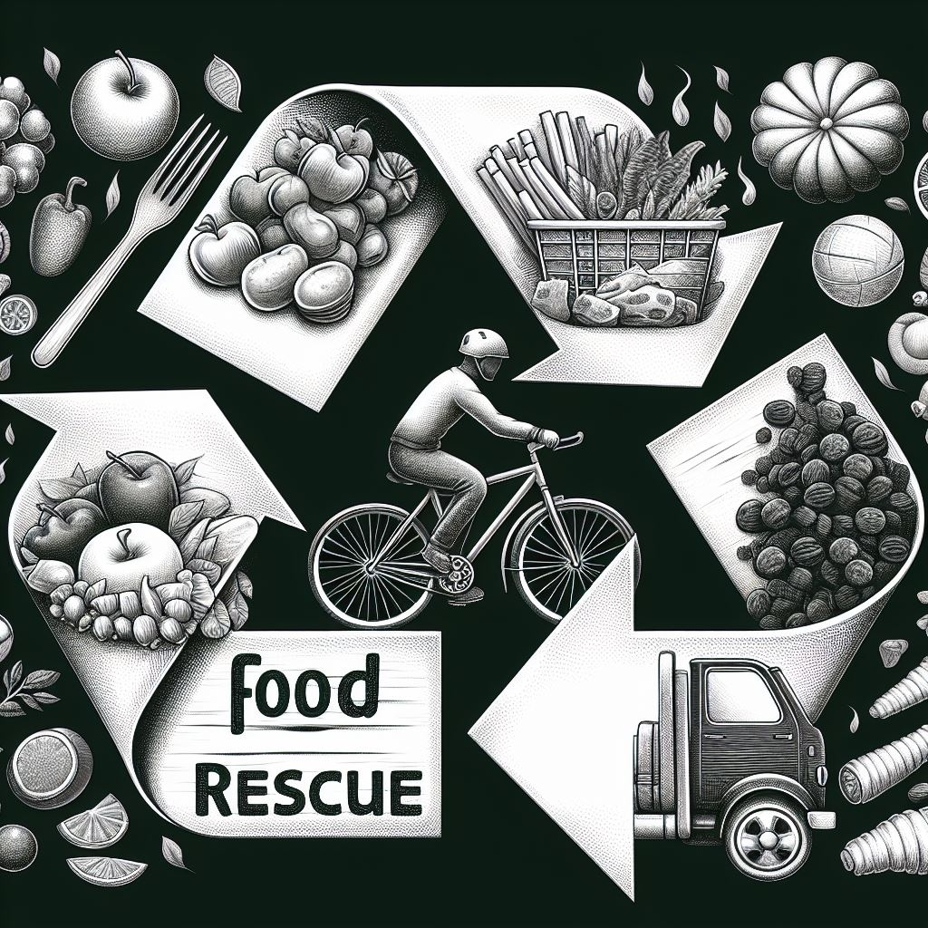 | 

