 | Monday | Tuesday | Wednesday | Thursday | Friday
10:00 - 11:00 |  |  |  | 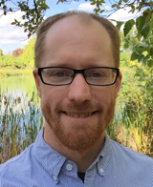  Dan Visscher  Teaching this year:  MATH 101  MATH 187  MATH 248  Tech Specialties:  Mathematica | 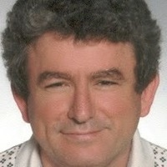  Osman Yurekli  Teaching this year:  MATH 111  MATH 211  MATH 262  Tech Specialties:  Mathematica
11:00 - 12:00 |  |  | 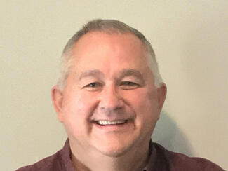  Dave Brown  Teaching this year:  MATH 10401  MATH 144  Tech Specialties:  Python  R (for calculus)  Mathematica | 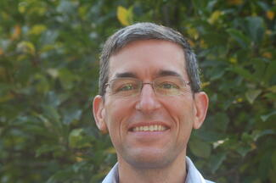  Ted Galanthay  Teaching this year:  MATH 148  Tech Specialties:  R, Mathematica
12:00 – 1:00
01:00 - 02:00 | 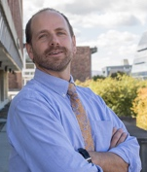  Tom Pfaff  Teaching this year:  MATH 10410  MATH 145  Tech Specialties:  R |  | 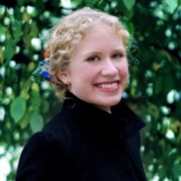  Megan Martinez  Teaching this year:  MATH 155  MATH 321  Tech Specialties:  Python/CoCalc  Tinkerplots | 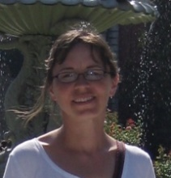  Emilie Wiesner  Teaching this year:  MATH 155  MATH 348  Tech Specialties:  Tinkerplots | 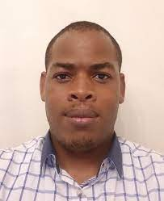  Joash Geteregechi  Teaching this year:  MATH 101  MATH 144  Tech Specialties:  R, Tinkerplots, SPSS
02:00 - 03:00 | 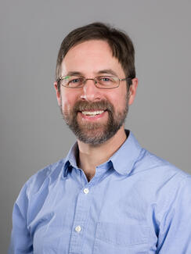  Aaron Weinberg  Teaching this year:  MATH 108  Tech Specialties: R  Tinkerplots
Evening
(In W209 unless another room is given.)
Mathematics Support Center
Williams 209

